**Data Collection and Preprocessing Phase**

|  |  |
| --- | --- |
| Date | 20 June 2024 |
| Team ID | 739900 |
| Project Title | Predicting Permanent Magnet Resistance Of Electronic Motor Using Machine Learning. |
| Maximum Marks | 6 Marks |

**Data Exploration and Preprocessing Report** :

Dataset variables will be statistically analyzed to identify patterns and outliers, with Python employed

for preprocessing tasks like normalization and feature engineering. Data cleaning will address missing values and outliers, ensuring quality for subsequent analysis and modeling, and forming a strong foundation for insights and predictions.

|  |  |
| --- | --- |
| Univariate Analysis |  |
| **Section** | **Description** |
| Data  Overview | Dimension:  28115rows × 9 Columns Descriptive Descriptive statistics: |

|  |  |
| --- | --- |
|  |  |

|  |  |
| --- | --- |
| Outliers and Anomalies | - |
| **Data Preprocessing Code Screenshots** | |

|  |  |
| --- | --- |
| Multivariate Analysis |  |

Loading Data

data=pd.read_csv(

"/content/measures_v2.csv"

)

df.head()

Handling

Missing Data

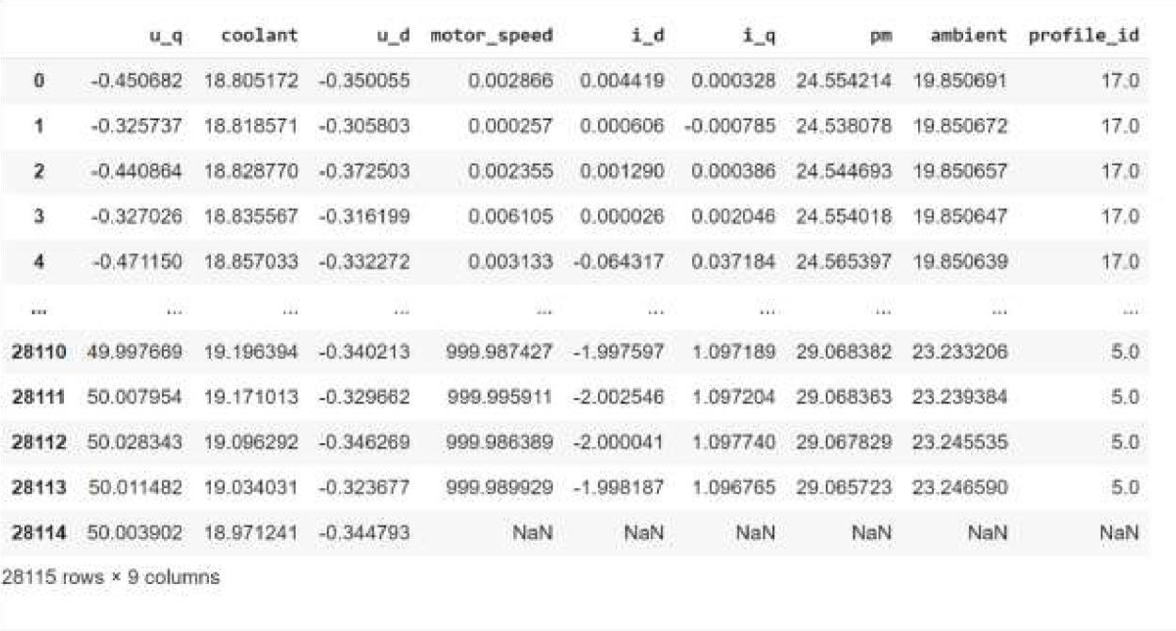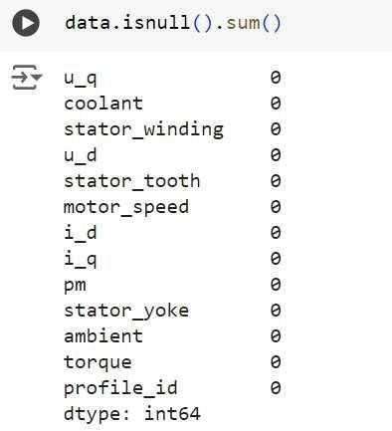

|  |  |
| --- | --- |
| Data  Transformation | ----- |
| Feature  Engineering | Attached the codes in final submission. |
| Save  Processed Data | - |